**07-03-2024** 

**BSNL cable types**

BSNL (Bharat Sanchar Nigam Limited) is a telecommunications company in India that provides a wide range of services, including landline, mobile, and broadband internet. BSNL uses various types of cables in its network infrastructure to deliver these services. Some common cable types used by BSNL include:

## **What is an optical fibre?**

Optical Fiber is a data transmission method that makes use of light pulses traveling down a long fibre, often constructed of plastic or glass. The less signal damage metal wires can cause, the better for optical Fiber connection. Additionally, electromagnetic interference does not impact optical Fibers. The total internal reflection of light is used in the **fibre optic cable.**

**Structure of optical fiber**:

1. **Optical Fiber Cables (OFC):**
   * BSNL uses optical Fiber cables for its broadband internet and **high-speed data** **services.**
   * These cables transmit data using light signals through strands of **glass Fibers,** **offering high bandwidth and long-distance transmission capabilities.**
   * BSNL deploys OFC for its Bharat Net project, which aims to provide **broadband connectivity to rural areas in India.**
2. **Copper Telephone Cables:**
   * BSNL uses copper telephone cables for providing landline telephone services to its customers.
   * These cables consist of twisted pairs of copper wires and are used for voice communication over the Public Switched Telephone Network (PSTN).
   * Copper telephone cables are also used for delivering Digital Subscriber Line (DSL) internet services, which utilize existing telephone infrastructure for broadband connectivity.
3. **Coaxial Cables:**
   * BSNL may use coaxial cables for delivering cable television (CATV) services, which are sometimes bundled with broadband internet and voice services.
   * Coaxial cables are capable of **transmitting high-frequency signals** and are commonly used for distributing television signals in cable TV networks.
4. **Ethernet Cables:**
   * BSNL uses Ethernet cables, such as Category 5e (Cat5e) or Category 6 (Cat6) cables, for providing Ethernet-based broadband internet services to customers.
   * **These cables are used for connecting customer premises equipment (CPE) such as routers, modems, and computers to BSNL's network infrastructure.**
5. **Fiber-to-the-Home (FTTH) Cables:**
   * BSNL may deploy FTTH cables in areas where it offers fiber-to-the-home broadband services.
   * FTTH cables are designed to deliver high-speed internet directly to customers' homes using optical fiber technology.

These are some of the common cable types used by BSNL in its telecommunications network infrastructure to deliver various services such as broadband internet, landline telephone, and cable television. The specific types of cables deployed by BSNL may vary depending on factors such as the type of service offered, geographic location, and network architecture.

**BSNL Drop Cable, Packaging Type: 500 Meter Coil, Mode Type: Multi Mode**

**Get Latest Price**

|  |  |
| --- | --- |
| Material | PVC/HDPE |
| Mode Type | Multi Mode |
| Packaging Type | 500 Meter coil |
| Conductor Stranding | Solid |

### Related categories :

* [Drop Wire](https://dir.indiamart.com/impcat/drop-wire.html)
* [Pvc Wire](https://dir.indiamart.com/impcat/pvc-wire.html)
* [Fiber Optic Cable](https://dir.indiamart.com/impcat/fiber-optic-cable.html)
* [Telephone Cables](https://dir.indiamart.com/impcat/telephone-cables.html)
* [Communications Cable](https://dir.indiamart.com/impcat/communications-cables.html)
* [Telecom Cable](https://dir.indiamart.com/impcat/telecommunication-cable.html)
* [Wires](https://dir.indiamart.com/impcat/wires.html)
* [Electric Wire](https://dir.indiamart.com/impcat/electrical-wires.html)
* [2 Core Cable](https://dir.indiamart.com/impcat/2-core-cable.html)
* [Fiber Optic Patch Cord](https://dir.indiamart.com/impcat/fiber-optic-patchcord.html)
* [Jelly Filled Telephone Cables](https://dir.indiamart.com/impcat/jelly-filled-telephone-cables.html)
* [Loose Tube Fiber Optic Cable](https://dir.indiamart.com/impcat/loose-tube-fiber-optic-cable.html)
* [Spiral Cable](https://dir.indiamart.com/impcat/spiral-cable.html)
* [Telephone Cords](https://dir.indiamart.com/impcat/telephone-cords.html)
* [Unshielded Telecommunication Cables](https://dir.indiamart.com/impcat/unshielded-cables.html)
* [V Guard Telecommunication Cable](https://dir.indiamart.com/impcat/v-guard-telecommunication-cable.html)
* **Patch Cord**

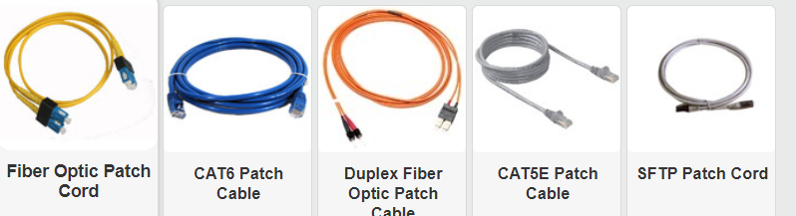

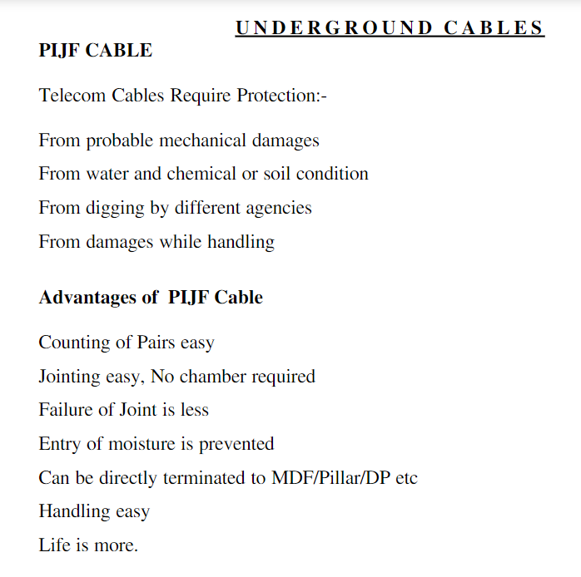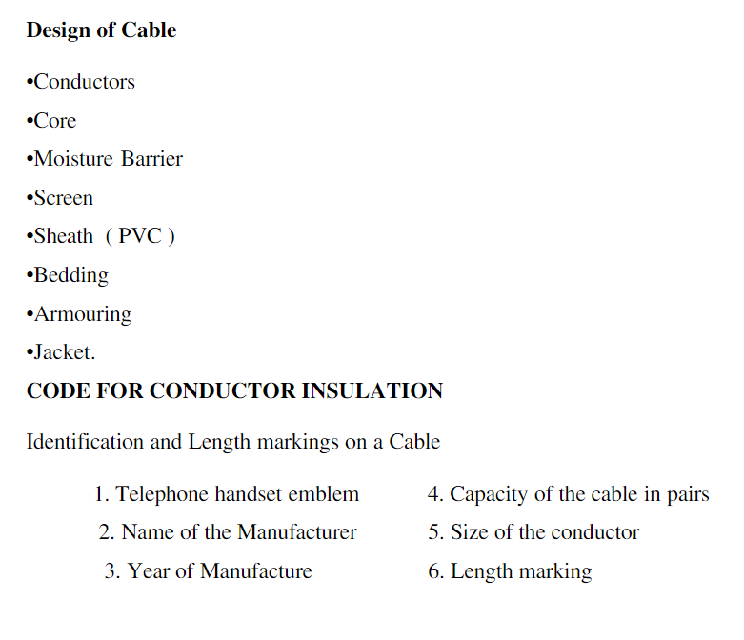

BSNL (Bharat Sanchar Nigam Limited) uses various types of cables for its telecommunications infrastructure. Some of the common types of cables used by BSNL include:

1. **Optical** **Fiber Cables (OFC):** BSNL extensively uses optical fiber cables for long-distance communication due to their high bandwidth and low signal loss characteristics. OFC is used for both voice and data transmission.
2. **Coaxial Cables:** Coaxial cables are used by BSNL for transmitting television signals, internet services, and other broadband applications. These cables consist of a central conductor surrounded by insulation, a metallic shield, and an outer insulating layer.
3. **Twisted Pair Cables**: Twisted pair cables are used for telephone lines and DSL (Digital Subscriber Line) services. They consist of pairs of insulated copper wires twisted together to reduce electromagnetic interference.
4. **Submarine Cables**: BSNL also utilizes submarine cables for international communication links. These cables are laid on the ocean floor and connect different countries to facilitate international telecommunication services.
5. **Aerial Cables:** Aerial cables are used for **overhead transmission lines, especially in rural and remote areas.** These cables are suspended from poles or towers and provide connectivity for voice and data services.

**2 What are the SPLICING types used in fiber network**

In fiber optic networks, splicing is the process of joining two optical fibers together to create a continuous optical path. There are several types of splicing techniques used in fiber optic networks, including:

1. **Fusion Splicing:** Fusion splicing is a permanent joining technique where the ends of two optical Fibers are aligned and then fused together using an **electric arc or a laser.** This process results in a low-loss connection with minimal reflectance. Fusion splicing is commonly used in long-haul telecommunications networks and high-spee.d data transmission applications.
2. **Mechanical Splicing:** Mechanical splicing involves aligning the ends of two optical fibers within a specially designed splice assembly that holds them in place. Unlike fusion splicing, mechanical splicing does not involve melting the fibers together. Instead, it uses precise alignment and physical contact between the fiber ends to create a low-loss connection. Mechanical splicing is often used for temporary connections, testing, and in situations where fusion splicing equipment is not available.
3. **Ribbon Splicing:** Ribbon splicing is a specialized form of fusion splicing used for multi-fiber ribbons, where multiple fibers are bonded together in a flat ribbon-like structure. Ribbon splicing equipment is designed to align and fuse the entire ribbon at once, enabling faster splicing of multiple fibers simultaneously. This technique is commonly used in high-density fiber optic cables and large-scale data center installations.
4. **Mass Fusion Splicing:** Mass fusion splicing is a high-through put fusion splicing technique used for joining multiple fibers simultaneously. It involves aligning the ends of multiple fibers within a fusion splicing machine and fusing them together in a single operation. Mass fusion splicing is commonly used in large-scale fiber optic cable deployments, such as in backbone networks and fiber-to-the-home (FTTH) installations.

These are some of the main splicing techniques used in fiber optic networks. The choice of splicing technique depends on factors such as the application, the type of fibers being spliced, and the required level of performance and reliability.

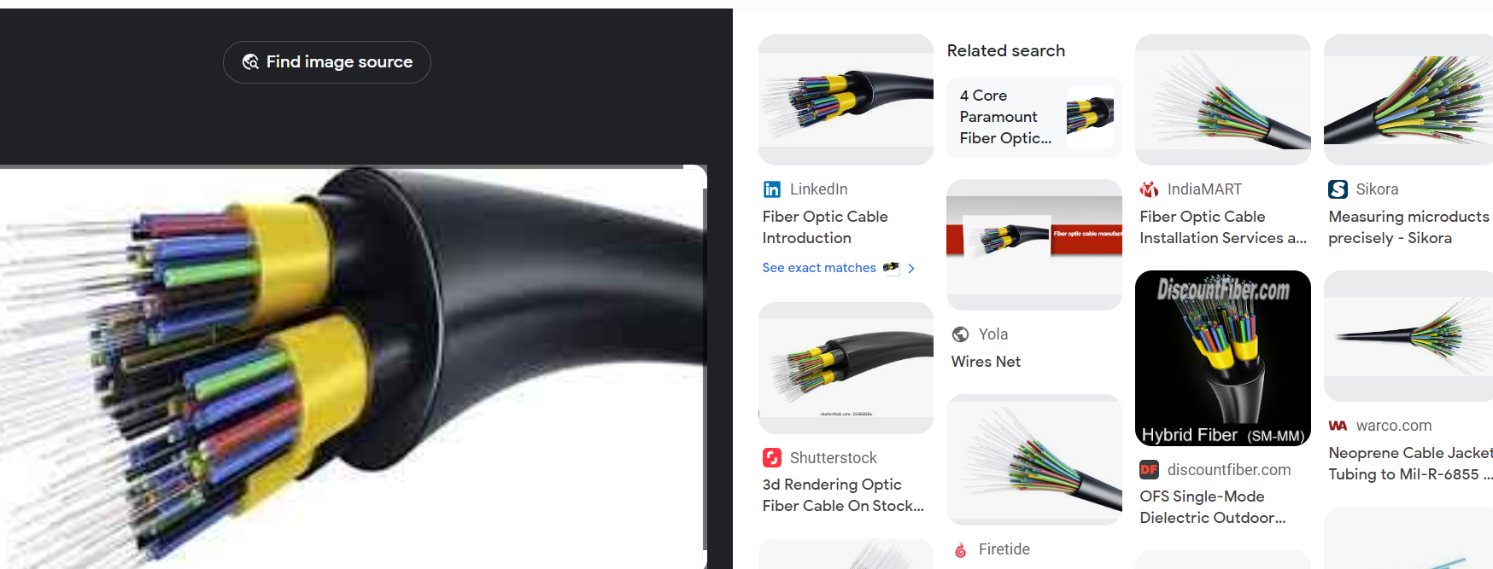

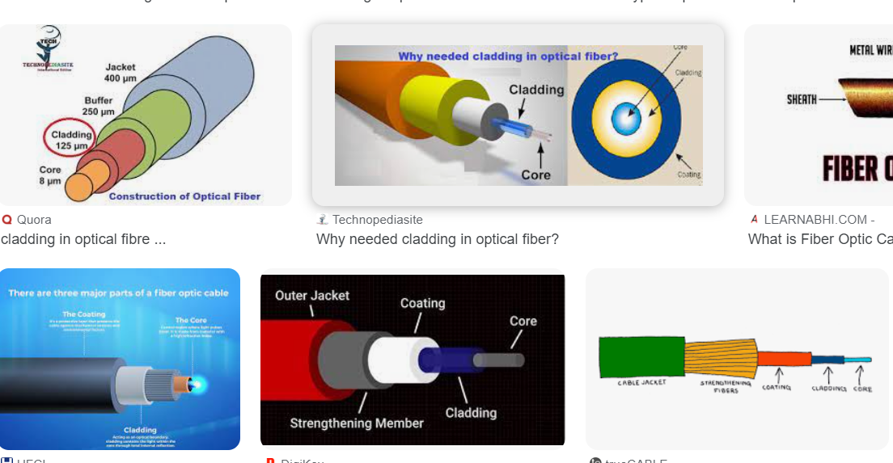

**What is Cladding**

In the context of cables, "cladding" refers to a protective layer or coating that surrounds the core of the cable. This layer is designed to provide mechanical strength, environmental protection, and sometimes additional functionality to the cable.

For fiber optic cables, which consist of a core made of glass or plastic fibers, the cladding is a layer that surrounds the core. The primary purpose of the cladding in fiber optic cables is to confine the light within the core by reflecting it back into the core, thus allowing for efficient transmission of light signals through the fiber.

In electrical cables, such as power cables or coaxial cables, the cladding may refer to an outer layer of insulation or shielding that surrounds the conductive core. This cladding provides protection against environmental factors such as moisture, chemicals, and physical damage, and it also helps to prevent electromagnetic interference (EMI) or radio frequency interference (RFI) from affecting the signal transmission within the cable.

In general, the cladding in cables serves to protect and enhance the performance of the core components, whether they are optical fibers or conductive wires, by providing insulation, mechanical support, and environmental resistance.

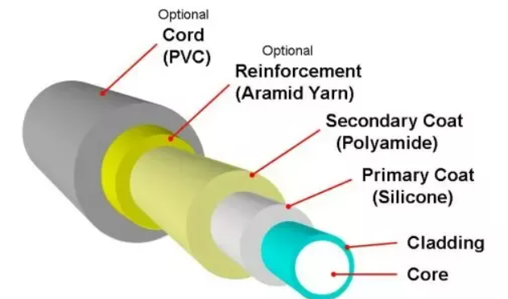

**Fiber layers and its types**

In fiber optic cables, there are typically three layers:

1. **Core:** The core is the central part of the fiber through which light propagates. It is made of either glass or plastic and is designed to carry the light signal.
2. **Cladding:** The cladding is a layer surrounding the core. Its primary function is to confine the light within the core by reflecting it back into the core, allowing for efficient transmission of light signals through the fiber. The cladding is usually made of a material with a lower refractive index than the core.
3. **Buffer Coating**: The buffer coating is an outer layer that provides mechanical protection to the core and cladding. It is usually made of a polymer material such as acrylate or silicone. The buffer coating helps to protect the fiber from physical damage, moisture, and environmental factors.

Types of fiber optic cables based on the number of layers:

1. **Single-mode Fiber:** Single-mode fiber optic cables have a core with a very small diameter, typically around 9 microns. They are designed to carry a single mode of light, which allows for longer transmission distances and higher bandwidth compared to multimode fibers. Single-mode fibers are commonly used in long-distance telecommunications and data transmission applications.
2. Multimode Fiber: Multimode fiber optic cables have a larger core diameter, typically around **50 or 62.5 microns**. They are capable of carrying multiple modes of light, which results in **shorter transmission distances and lower bandwidth compared to single-mode fibers.** Multimode fibers are commonly used in shorter-distance communication applications such as local area networks (**LANs) and fiber-to-the-home (FTTH**) connections.

These are the main types of fiber optic cables based on the number of layers and their respective characteristics. The choice between single-mode and multimode fiber depends on factors such as the required transmission distance, bandwidth, and application requirements.

**What is Acceptable Loss ?**

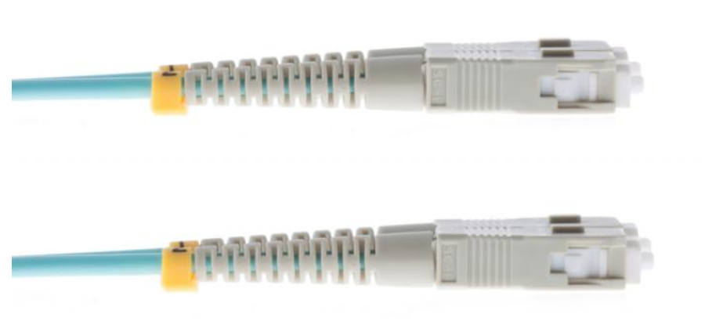

Acceptable fiber loss refers to the maximum amount of signal attenuation that can be tolerated in an optical fiber network without significant degradation in performance. It is typically measured in decibels (dB) and depends on various factors such as the type of fiber, the length of the fiber link, and the specific application requirements. The acceptable fiber loss value is determined by considering the power budget and signal-to-noise ratio requirements of the network. In general, lower fiber loss is preferred as it allows for longer transmission distances and better signal quality.

### Fiber Optic Communication: Acceptable Loss Thresholds

The acceptable fiber loss in fiber optic communication refers to the amount of signal loss that can occur during transmission without significantly degrading the performance of the system. Fiber optic cables are designed to transmit light signals over long distances, but some signal loss is inevitable due to various factors such as attenuation, dispersion, and bending losses.  
  
The acceptable loss threshold depends on the specific application and the type of fiber optic system being used. In general, the acceptable loss range is typically between 0.2 dB/km to 0.5 dB/km for single-mode fibers, and 2 dB/km to 3 dB/km for multimode fibers. These values represent the maximum allowable loss per kilometer of fiber.  
  
However, it is important to note that the acceptable loss thresholds have evolved over time with advancements in fiber optic technology. With the development of low-loss fibers and more efficient components, the acceptable loss thresholds have become more stringent. In some high-speed and long-distance applications, the acceptable loss thresholds can be as low as 0.1 dB/km or even lower.

**what is fiber loss**

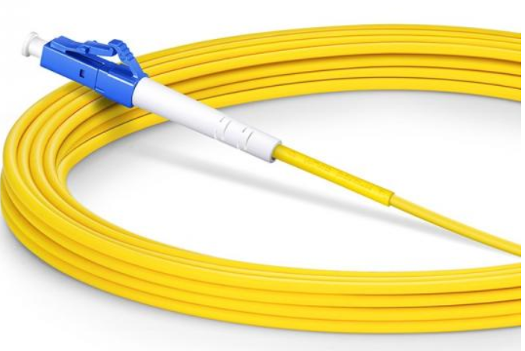

Fiber loss refers to the reduction in signal strength or quality that occurs as light travels through an optical fiber. This loss can be caused by various factors such as absorption, scattering, and bending of the light within the fiber, as well as imperfections in the fiber itself.

The main causes of fiber loss include:

1. Absorption: Some materials used in optical fibers can absorb light at certain wavelengths, leading to a reduction in signal strength as the light travels through the fiber.
2. Scattering: Light can scatter in different directions as it interacts with imperfections or irregularities in the fiber material, leading to a loss of signal strength.
3. Bending Loss: When the fiber is bent beyond a certain radius, light can escape from the core, resulting in signal loss. This is particularly significant in tight bends or when fibers are coiled.
4. Connector and Splice Loss: When optical fibers are connected or spliced together, some light can be lost at these junction points due to reflections or misalignment of the fibers.
5. Modal Dispersion: In multimode fibers, different light rays (modes) can travel through the fiber at different speeds, leading to dispersion and loss of signal integrity over long distances.

Fiber loss is typically expressed in decibels per kilometer (dB/km) and is an important consideration in designing and deploying optical fiber communication systems. Minimizing fiber loss is crucial for ensuring efficient transmission of signals over long distances in fiber optic networks.

Top of Form

**Fiber losses per km**

The losses in optical fibers are typically measured in decibels per kilometer (dB/km). The actual amount of loss can vary depending on factors such as the type of fiber, the wavelength of light being used, and the quality of the fiber installation. Here are some general ranges for fiber losses per kilometer:

1. **Single-Mode Fiber:**
   * Typical loss: 0.2 dB/km to 0.5 dB/km
   * Advanced low-loss fibers: 0.18 dB/km to 0.25 dB/km
2. **Multimode Fiber:**
   * Standard multimode fibers: 2 dB/km to 5 dB/km
   * Graded-index multimode fibers: 1 dB/km to 2 dB/km

These values are approximate and can vary depending on the specific characteristics of the fiber and the conditions under which it is deployed. Lower loss fibers are typically more expensive but can support longer transmission distances with minimal signal degradation.

**what are the joint closure types**

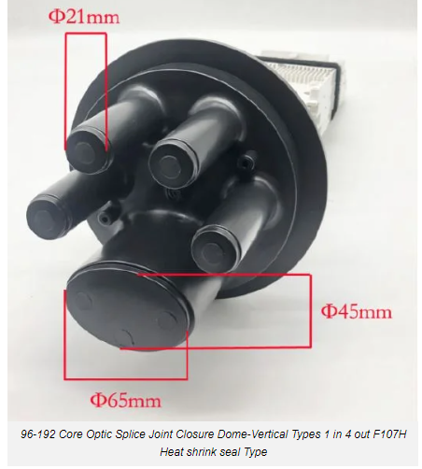

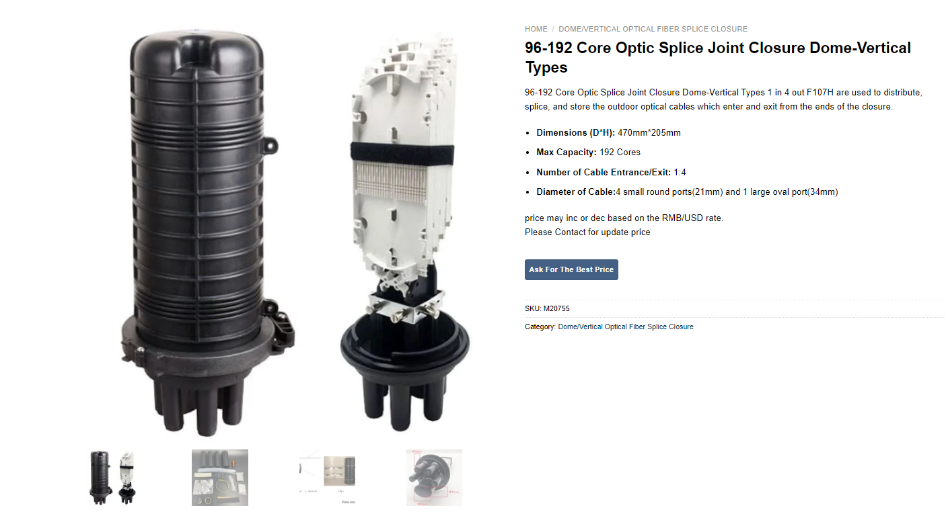

Joint closures, also known as splice closures, are used in fiber optic networks to protect and manage the splices or connections between optical fibers. There are several types of joint closures commonly used in fiber optic installations, each designed for specific applications and environmental conditions. Some of the common joint closure types include:

1. **Dome Closure:** Dome closures are typically used for aerial, buried, or underground applications. They consist of a dome-shaped housing that provides protection against moisture, dust, and other environmental factors. Dome closures often have multiple entry and exit ports for incoming and outgoing fibers.
2. **In-line Closure:** In-line closures are designed for use in straight cable runs where the fibers do not need to be redirected. They are usually compact and cylindrical in shape, making them suitable for limited space installations. In-line closures are commonly used in long-haul fiber optic networks.
3. **Vertical Closure**: Vertical closures are similar to dome closures but have a vertical design, making them suitable for installations where space is limited horizontally. They provide protection against moisture and other environmental factors and are often used in aerial or pole-mounted applications.
4. **Horizontal Closure:** Horizontal closures are designed for use in underground or buried installations where the fibers need to be routed horizontally. They typically have a flat, rectangular shape and provide a secure seal to protect the splices from moisture and other external elements.
5. **Dome-to-Dome Closure:** Dome-to-dome closures are used to connect two dome closures together in a continuous fiber optic network. They provide a sealed enclosure for the splices and connections between the two closures, ensuring protection against environmental factors.
6. Fiber Distribution Hub (FDH): FDH closures are used in fiber-to-the-home (FTTH) and fiber-to-the-premises (FTTP) installations to distribute fiber optic cables to multiple subscribers or premises. They often include features such as splitters, splice trays, and distribution panels for managing and organizing the fiber connections.

These are some of the common types of joint closures used in fiber optic networks, each designed to meet specific installation requirements and environmental conditions. The choice of closure type depends on factors such as the installation location, cable routing, and required protection levels.

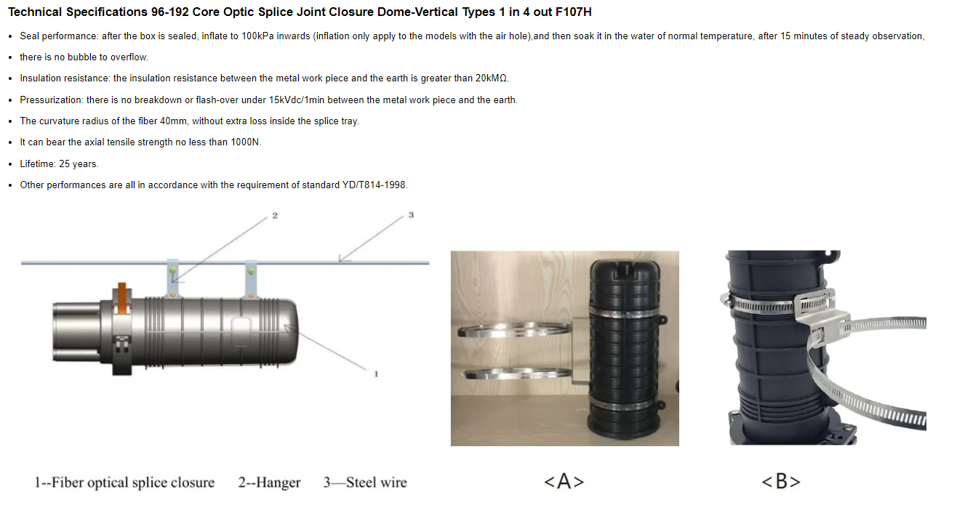Top of Form



**what is FDMS fiber distribution management system**

A Fiber Distribution Management System (FDMS) is a system used to manage and monitor fiber optic networks. It provides tools for network operators to efficiently deploy, monitor, and maintain their fiber optic infrastructure.

Key features of a Fiber Distribution Management System may include:

1. **Network Planning and Design:** FDMS software often includes tools for designing fiber optic networks, including planning routes, determining optimal cable placements, and calculating network capacity.
2. **Inventory Management:** It tracks the inventory of fiber optic cables, connectors, splices, and other network components. This helps in maintaining an accurate record of available resources and managing replacements or upgrades.
3. **Asset Management:** FDMS tracks the physical location and status of network assets such as cables, splices, and termination points. This information is crucial for troubleshooting and maintenance.
4. **Monitoring and Control:** It provides real-time monitoring of network performance, including signal strength, bandwidth usage, and fault detection. Operators can remotely control network components and perform diagnostics to identify and resolve issues.
5. **Documentation and Reporting:** FDMS maintains detailed documentation of the network layout, including cable routes, splice points, and termination points. It also generates reports on network performance, maintenance activities, and resource utilization.
6. **Integration with Other Systems:** FDMS may integrate with other network management systems, such as Geographic Information Systems (GIS), Customer Relationship Management (CRM), and Billing Systems, to provide a comprehensive view of the network and its operations.

Overall, Fiber Distribution Management Systems play a crucial role in ensuring the efficient operation and maintenance of fiber optic networks, which are essential for delivering high-speed internet and other telecommunications services.

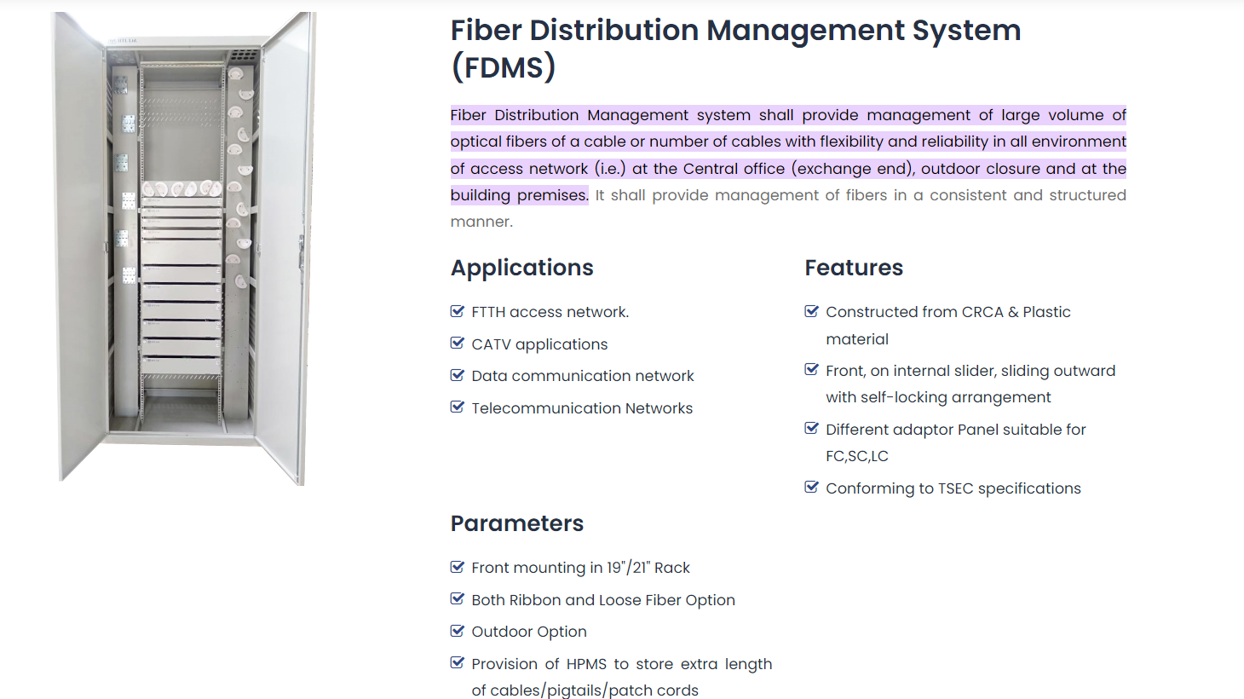Top of Form

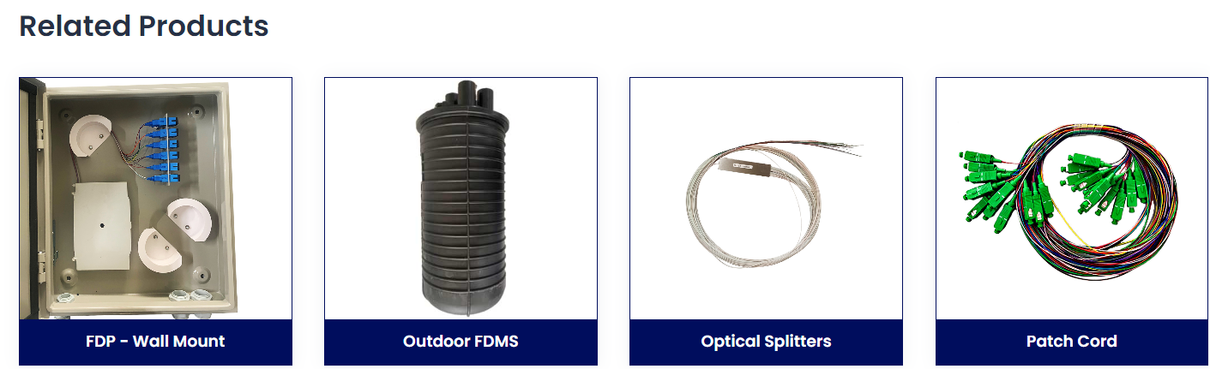

**what are the patch cord types**

Patch cords are essential components in telecommunications and networking systems, used to connect various devices, such as computers, switches, routers, and other network equipment. There are several types of patch cords commonly used in networking environments, each designed for specific purposes. Here are some of the most common patch cord types:

1. **Unshielded Twisted Pair (UTP) Patch Cord:**
   * UTP patch cords are the most common type of patch cord used in Ethernet networks.
   * They consist of four pairs of twisted copper wires, usually terminated with RJ45 connectors.
   * UTP patch cords are used for connecting devices such as computers, switches, routers, and patch panels in local area networks (LANs).
   * 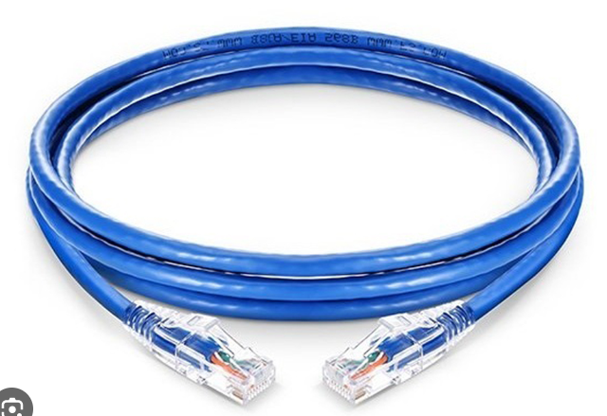
2. **Shielded Twisted Pair (STP) Patch Cord:**
   * STP patch cords are similar to UTP patch cords but with additional shielding to protect against electromagnetic interference (EMI) and radio frequency interference (RFI).
   * They are commonly used in environments with high levels of electromagnetic interference, such as data canters and industrial facilities.
   * 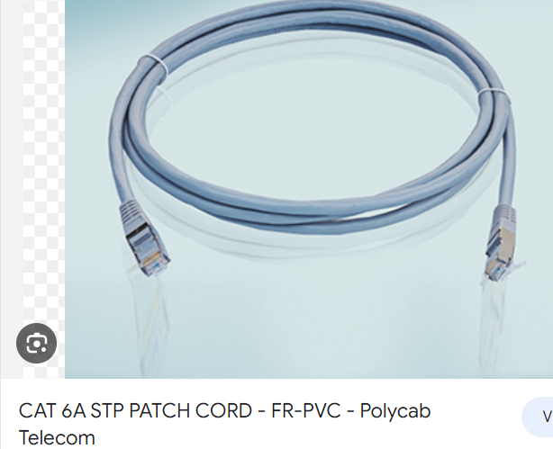
3. **Fiber Optic Patch Cord:**
   * Fiber optic patch cords are used to transmit data using light signals over optical fibers.
   * There are various types of fiber optic patch cords, including single-mode and multimode, as well as different connector types such as LC, SC, ST, and MTP/MPO.
   * They are used in high-speed data transmission applications, such as long-distance networking, telecommunications, and data center interconnects.
   * 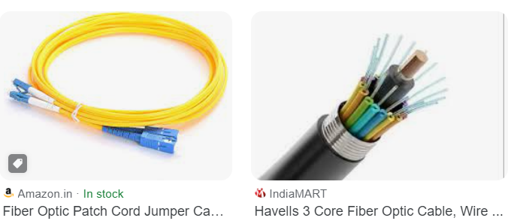
4. **Coaxial Patch Cord:**
   * Coaxial patch cords consist of a central conductor surrounded by a dielectric insulator, a shielding layer, and an outer insulating layer.
   * They are commonly used in cable television (CATV) systems, CCTV installations, and other applications requiring high-frequency signal transmission.
   * 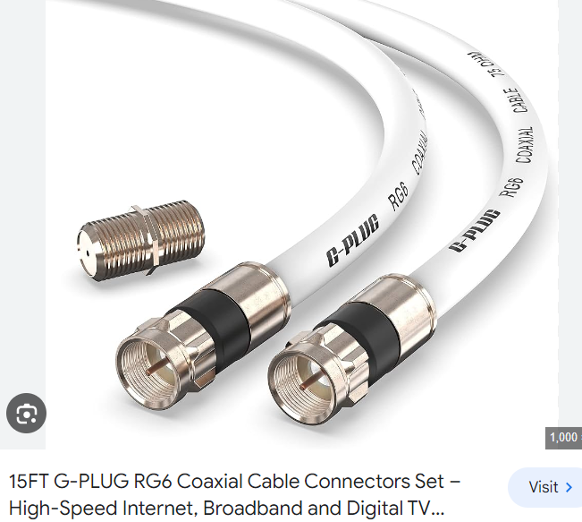
5. **Modular Patch Cord:**
   * Modular patch cords are used in telecommunications and networking systems to connect devices with modular jacks, such as telephone systems and Ethernet networks.
   * They are commonly terminated with modular connectors such as RJ11, RJ12, or RJ45.
6. **Power over Ethernet (PoE) Patch Cord:**
   * PoE patch cords are used to deliver electrical power and data over Ethernet cables simultaneously.
   * They are commonly used in IP camera installations, VoIP phones, and other devices that require both power and data connectivity over Ethernet.

These are some of the most common types of patch cords used in networking and telecommunications systems. The choice of patch cord type depends on factors such as the application, environment, and specific requirements of the network installation.

User

**splitter types Telecommunication**

In the context of telecommunications, splitters are devices used to divide or combine signals in various ways to facilitate the distribution of information within a network. Here are some common types of splitters used in telecommunications:

1. **Fiber Optic Splitter:**
   * Fiber optic splitters are crucial in passive optical networks (PONs) to split an incoming optical signal into multiple signals, allowing one optical line to serve multiple users.
   * Types include Fused Biconic Taper (FBT) splitters and Planar Lightwave Circuit (PLC) splitters.
   * 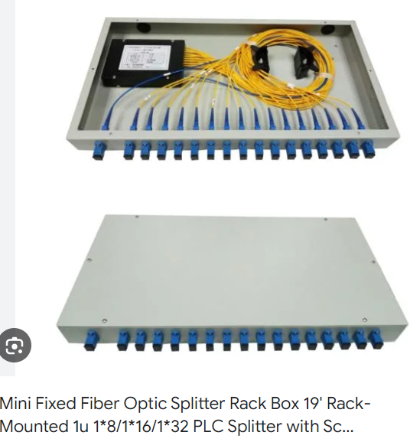
2. **Coaxial Cable Splitter:**
   * Coaxial cable splitters are used in cable television (CATV) systems to split the incoming cable signal for distribution to multiple televisions or devices.
   * These are commonly used in residential and commercial settings for distributing cable TV signals.
3. **Microwave Splitter:**
   * Microwave splitters are used in microwave communication systems to split signals for distribution to multiple antennas or receivers.
   * These are essential components in point-to-point and point-to-multipoint microwave links.
4. **Power Splitter:**
   * Power splitters in telecommunications are used to divide electrical power into multiple paths for distribution to various devices.
   * They are commonly used in base station installations and distributed antenna systems (DAS) for powering multiple components.
5. **RF Splitter:**
   * RF (Radio Frequency) splitters are used in wireless communication systems to split RF signals for distribution to multiple antennas or devices.
   * These splitters play a role in distributing signals in cellular networks and other wireless communication setups.
6. **Telephone Line Splitter:**
   * Telephone line splitters are used in traditional telephony setups to split a single telephone line into multiple lines, allowing multiple phones to share the same line.
   * They are common in residential and small business telephone installations.
7. **TDM (Time-Division Multiplexing) Splitter:**
   * TDM splitters are used in telecommunications networks to divide time slots within a communication channel for multiple users.
   * TDM is a technique where different signals are transmitted in sequential time slots over the same communication channel.
8. **Signal Combiner/Splitter:**
   * These versatile devices are used in various telecommunications setups to either combine or split signals as needed.
   * They may be used in test and measurement applications or in scenarios where signals need to be distributed or aggregated efficiently.

The specific type of splitter used in a telecommunications network depends on the technology, the nature of the signals being transmitted, and the network architecture. Different splitters are employed at different points within the network to ensure effective signal distribution and communication.

**what is OTDR and its use :**

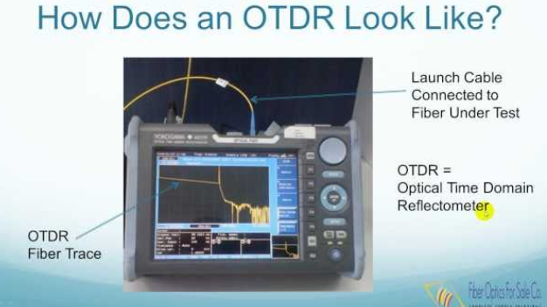

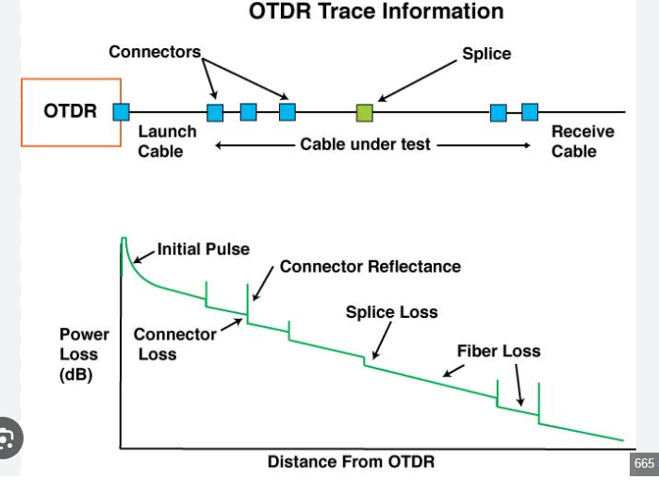

OTDR stands for Optical Time Domain Reflectometer. It's a specialized piece of equipment used in optical fiber communications and networking to characterize the performance of fiber optic cables. OTDRs are essential tools for installing, maintaining, and troubleshooting fiber optic networks. Here's a brief overview of what OTDRs are and why they are used:

1. **Principle of Operation:**
   * OTDRs work based on the principle of sending short pulses of light into a fiber optic cable and measuring the backscattered and reflected light as it travels along the length of the cable.
   * By analyzing the time and intensity of the reflected light signals, an OTDR can determine various properties of the fiber optic cable, such as attenuation, splice loss, connector loss, and fiber length.
2. **Key Features and Functions:**
   * Distance Measurement: OTDRs can accurately measure the length of fiber optic cables by analyzing the time taken for light to travel along the cable and return.
   * Fault Location: OTDRs can pinpoint the location of fiber breaks, bends, or other faults within the cable by analyzing the backscattered and reflected light signals.
   * Loss Measurement: OTDRs can measure the optical loss (attenuation) along the length of the fiber optic cable, including losses at connectors and splices.
   * Fiber Characterization: OTDRs provide detailed information about the characteristics of the fiber optic cable, including its attenuation profile, splice locations, and connector quality.
3. **Uses of OTDRs:**
   * Installation: OTDRs are used during the installation of fiber optic cables to verify the quality of the installation, measure cable lengths, and identify any faults or issues.
   * Maintenance: OTDRs are used for routine maintenance of fiber optic networks to detect and locate faults, assess the condition of the cables, and ensure optimal performance.
   * Troubleshooting: OTDRs are invaluable tools for troubleshooting fiber optic networks when issues arise, such as signal loss, network downtime, or performance degradation.
   * Quality Assurance: OTDR measurements are used to verify compliance with industry standards and specifications, ensuring that fiber optic networks meet performance requirements.

In summary, OTDRs are essential tools for characterizing, testing, and troubleshooting fiber optic cables in telecommunications and networking applications. They provide valuable information about the condition, performance, and quality of fiber optic networks, helping to ensure reliable and efficient communication.

**Splicing Machine**

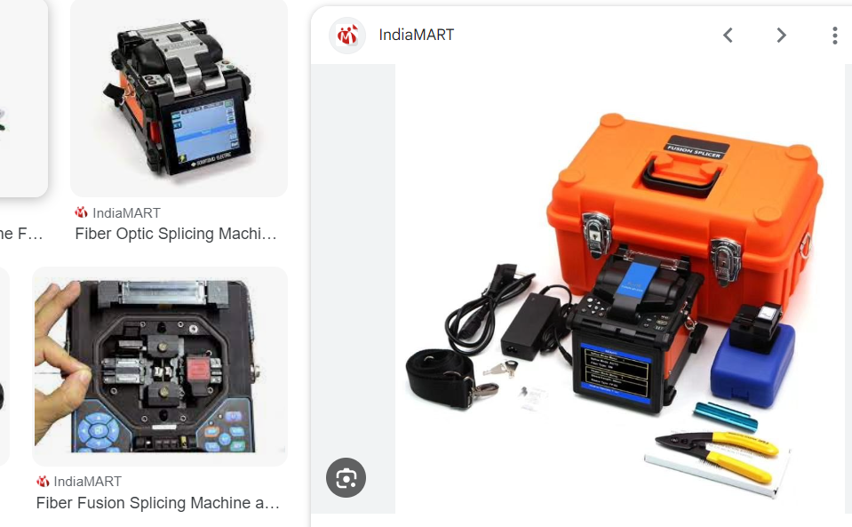

**What is fiber optic splicing machine?**

**A fiber optic fusion splicer is a device that uses an electric arc to melt two optical fibers together at their end faces, to form a single long fiber**.

**Optical Power Meter ?**

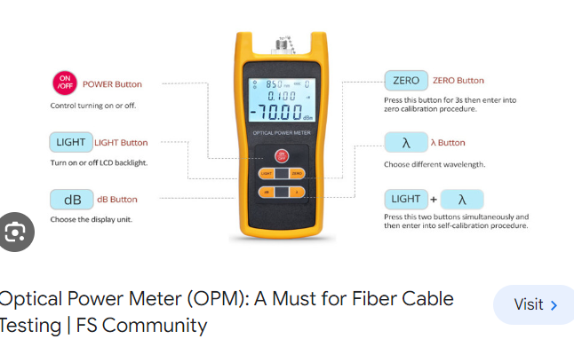

What is the maximum range of fiber optic cable?

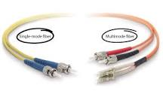

around 62.14 miles

Although the maximum distance of fiber optic cable is affected by both attenuation and dispersion, for most applications, the maximum distance of any type of fiber optic cable is around 62.14 miles (100 kilometers).15 May 2022

**CALCULATING FIBER LOSS AND DISTANCE ESTIMATES**

There are a number of ways to tackle the problem of determining the power requirements for a particular fiber optic link.

The easiest and most accurate way is to perform an Optical Time Domain Reflectometer (OTDR) trace of the actual link. This will give you the actual loss values for all events (connectors, splices, and fiber loss) in the link.

In the absence of an actual OTDR trace, there are two alternatives that can be used to estimate the power requirements of the link.

1. Estimate the total link loss across an existing fiber optic link if the fiber length and loss variables are known
2. Estimate the maximum fiber distance if optical budget and loss variables are known.

Loss variables are connectors, splices and attenuation per kilometer of the fiber.

If actual values for all of the loss variables are not known, as estimation for each is needed to complete the calculations. In this case, one would want to take a worst case approach to assure that there is adequate power available for the link.

The following table includes commonly accepted loss values used in these calculations.

|  |  |  |  |  |  |
| --- | --- | --- | --- | --- | --- |
| **Fiber Type** | **Wavelength** | **Fiber Attenuation /km (1)** | **Fiber Attenuation per km (2)** | **Connector Loss** | **Splice Loss** |
| Multimode 50/125um | 850nm | 3.5 dB | 2.5 dB | 0.75 dB | 0.1 dB |
| 1300nm | 1.5 dB | 0.8 dB | 0.75 dB | 0.1 dB |
| Multimode 62.5/125um | 850nm | 3.5 dB | 3.0 dB | 0.75 dB | 0.1 dB |
| 1300nm | 1.5 dB | 0.7 dB | 0.75 dB | 0.1 dB |
| Single Mode 9um | 1310nm | 0.4 dB | 0.35 dB | 0.75 dB | 0.1 dB |
| Single Mode 9m | 1550nm | 0.3 dB | 0.22 dB | 0.75 dB | 0.1 dB |